
LESSON NOTE | DETAILED EXPLANATORY NOTES
BIOINFORMATICS
DNA EXTRACTION, AMPLIFICATION (PCR) & GEL ELECTROPHORESIS
GRADE 12 - BIOLOGY
■ ■ ■

What is DNA Analysis?
Before DNA can be read and studied, it must be removed from cells, copied so there is enough to work with, and checked. These are three linked practical processes: DNA extraction (getting pure DNA out of a sample), amplification by PCR (making millions of copies of a target sequence), and gel electrophoresis (separating and viewing DNA fragments by size). Together they are the hands-on foundation of DNA analysis, leading on to sequencing and analysis with tools such as BLAST and CLUSTAL.
This lesson brings these three techniques together into one workflow, and shows how they are used in real laboratory investigations.
Why These Processes Matter
- Extraction provides pure, undamaged DNA to work with.
- PCR amplifies a tiny amount of a target gene into millions of copies for analysis.
- Gel electrophoresis checks the size and purity of the DNA and separates the fragments.
- Together they prepare DNA for sequencing and comparison with known sequences.
DNA Extraction, Amplification (PCR) & Gel Electrophoresis
Key Learning Outcomes
By the end of this lesson, students should be able to:
- Describe how DNA is extracted from cells and why pure, undamaged DNA is needed.
- Describe the polymerase chain reaction (PCR) and its three repeated steps.
- Explain how gel electrophoresis separates DNA fragments by size.
- Put the three processes together into a complete DNA analysis workflow.
- Work safely in the laboratory and handle samples and reagents with care.
Safety, Materials and Good Practice
DNA work must be done safely and cleanly. Wear gloves and eye protection, handle chemicals (such as extraction buffers and stains) carefully, and use sterile technique to avoid contaminating samples with other DNA. The main equipment includes micropipettes, tubes, a centrifuge, a thermal cycler (for PCR), a gel tank and power supply (for electrophoresis), and a UV viewer to see the stained DNA. Reagents must be measured accurately and kept cold where required.
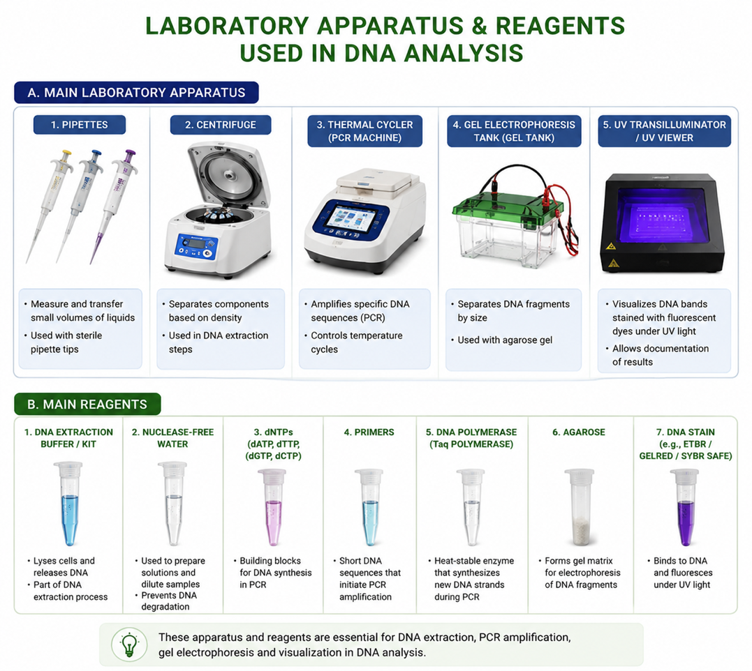
Figure 1: The main laboratory apparatus and reagents used in DNA analysis.
Glossary of Terms
Useful terms for these techniques:
- DNA extraction: the process of getting pure DNA out of cells.
- Lysis: breaking open cells to release their contents, including DNA.
- PCR (polymerase chain reaction): copying a target DNA sequence many times - “molecular photocopying.”
- Primer: a short DNA sequence that marks where PCR copying begins.
- Taq polymerase: the heat-stable enzyme that builds new DNA strands in PCR.
- Gel electrophoresis: separating DNA fragments by size using an electric current.
- DNA ladder: a set of fragments of known sizes, used to measure the sample fragments.
DNA Extraction
DNA extraction removes DNA from the cells of a sample (blood, tissue or plant material) and cleans away everything else. The cells are first broken open (lysis) using extraction buffers such as CTAB or phenol/chloroform, or a ready-made kit (solid-phase extraction). The proteins, lipids and other molecules are removed, and the DNA is then precipitated with alcohol and purified. A good extraction yields DNA in long, undamaged, pure strands. (If RNA is the target, it is first converted to complementary DNA (cDNA) using reverse transcriptase.)
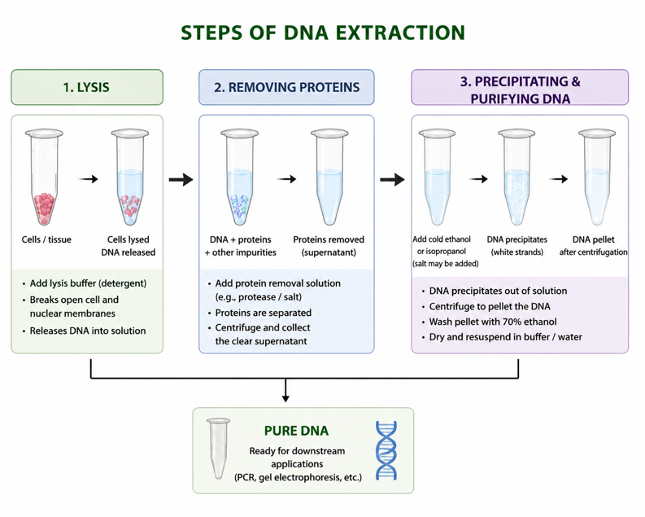
Figure 2: The main steps of DNA extraction.
Amplification by PCR
A sample usually contains far too little of the target DNA to study, so it is amplified by the polymerase chain reaction (PCR) - often called molecular photocopying. The reaction mixture contains the template DNA, two primers that flank the target, the four dNTPs, and heat-stable Taq polymerase. A thermal cycler then repeats three temperature steps:
- Denaturation (~94 °C): heat separates the double helix into two single strands.
- Annealing (~57–72 °C): the primers bind to their matching sequences on each strand.
- Elongation / extension (~72 °C): Taq polymerase builds new complementary strands.
Each cycle doubles the amount of the target DNA, so after about 30 cycles the tiny starting sample has become millions of copies - more than enough to analyse.
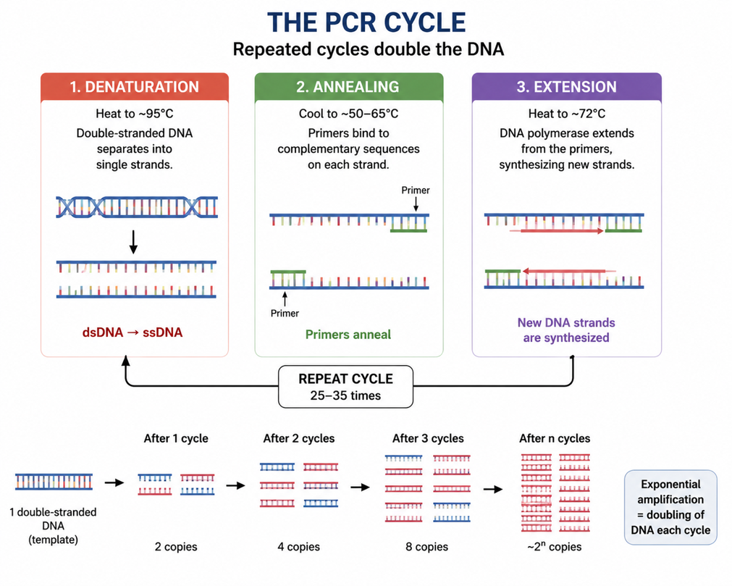
Figure 3: The polymerase chain reaction (PCR) - three repeated steps amplify the target DNA.
Gel Electrophoresis
Gel electrophoresis separates DNA fragments by size. The DNA samples are loaded into wells in a slab of agarose gel, and an electric current is applied across the gel. Because DNA carries a negative charge, it moves through the gel towards the positive electrode. Smaller fragments move faster and travel further, while larger ones lag behind, so the fragments spread out into separate bands. The DNA is then stained and viewed under UV light, and the band sizes are read against a DNA ladder of known sizes. Gel electrophoresis is used to check that PCR worked, to estimate fragment sizes, and to purify DNA before sequencing.
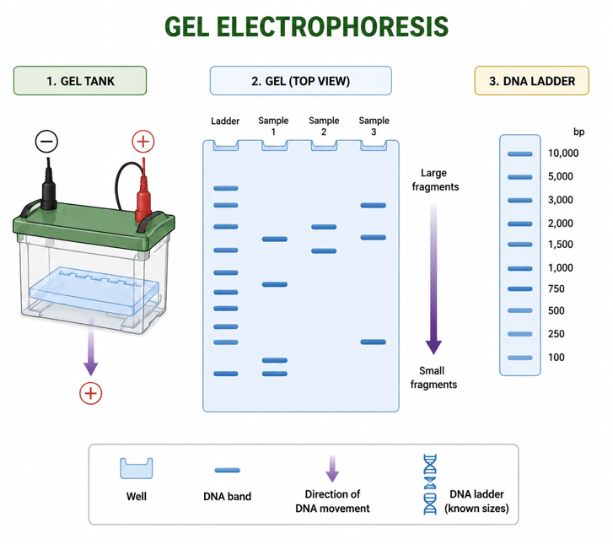
Gel electrophoresis – DNA fragments separate into bands according to their size..
The Complete DNA Analysis Workflow
The three processes fit together into one workflow. First the DNA is extracted from the sample; then the target gene is amplified by PCR; the products are checked and purified by gel electrophoresis; and finally the DNA is sequenced and the sequence is analysed - compared with known sequences using BLAST (single sequence) or CLUSTAL (multiple sequences). Each step depends on the one before it.
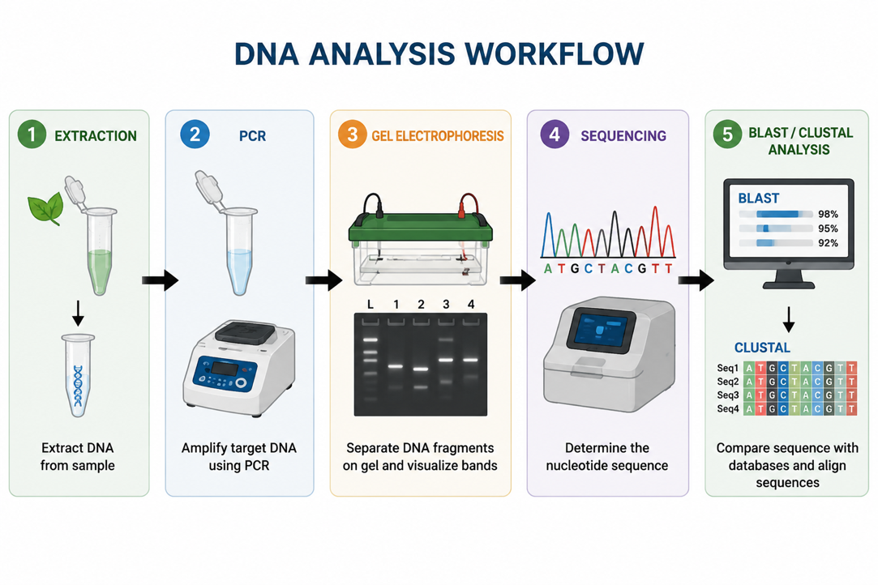
Figure 5: The complete DNA analysis workflow, from extraction to sequence analysis.
PNG Practical Example - Sequencing Cyclotide Genes
A real Grade-12 investigation studies cyclotides - medicinal plant peptides - in three species of Violaceae (violets) growing in PNG. The workflow follows the three steps of this lesson:
- Extract total DNA from the plant leaves (e.g. using the CTAB protocol).
- Design primers for the target gene and amplify it by PCR (denaturation 94 °C, annealing 57–72 °C, extension 72 °C, ~30 cycles).
- Purify the PCR products by gel electrophoresis.
- Sequence the DNA (this can be outsourced, e.g. to the University of Technology, PNG) and compare the sequences with known ones.
This shows how extraction, PCR and gel electrophoresis are used together in genuine scientific research carried out in Papua New Guinea.
Why This Matters
- Foundation of biotechnology - almost all DNA work begins with extraction, PCR and gel electrophoresis.
- Medicine & diagnostics - PCR detects pathogens (e.g. COVID-19, TB, HIV) and inherited conditions.
- Forensics & agriculture - DNA profiling, paternity testing, and improving crops and livestock.
- Research skills - these are the core practical skills for further study in the life sciences.
PNG Context Example
These techniques are increasingly used across Papua New Guinea - in health laboratories to detect and track pathogens such as malaria, tuberculosis and HIV, in agriculture to study and improve crops, and in universities to research the country's rich biodiversity (such as the cyclotide-producing plants above). Because PCR and gel electrophoresis need only modest equipment, they bring modern DNA analysis within reach of national laboratories.
References & Related Documents
Source Documents
- STEM Biology Student Resource Book - Grade 12, Term 1. Module 12.1 Bioinformatics, Topic 4: DNA Extraction, Amplification, Sequencing and Analysis (DNA Extraction; PCR Amplification; Gel Electrophoresis; Practical: Cyclotide Genes in Violaceae). Department of Education, PNG (2021).
- STEM Biology Syllabus - Grade 12, Term 1. Thema: Biotechnology; Module 12.1 Bioinformatics, Topic 4.
- Biology Standards-Based Syllabus, Grades 11 & 12 (PNG SBC 2020) - Strand 2: Life; investigate the structural properties of DNA and its role in heredity and protein synthesis; methods of gene technology.
Further Reading & References
- OpenStax Biology - Biotechnology (DNA cloning, PCR, gel electrophoresis). https://openstax.org/books/biology
- Khan Academy - Biotechnology: PCR and gel electrophoresis. https://www.khanacademy.org/science/biology

